A preliminary analysis of Pentlatch auxiliaries

Erin Hashimoto
University of Victoria
ehashimo@uvic.ca

The purpose of this project is to develop a preliminary understanding of Pentlatch motion auxiliary verb forms, functions, and constructions for the contemporary, community-led Pentlatch language reclamation. The project began by creating a format of the stories that is searchable, editable, and sortable from existing digital Boas legacy materials (Boas, ca. 1910) which revealed two motion verbs/auxiliaries: çō/çū meaning ‘go’ and mē meaning ‘come’. A comparative approach was also incorporated to determine these verbs’ possible functions in an auxiliary position. Additional examination of the contexts and translations in the stories was used to develop an idea of the grammatical information motion auxiliaries might contribute in Pentlatch, and to survey how other information might be included within, or in co-occurrence with, auxiliary constructions.
Keywords: Central Salish; language reclamation; motion; auxiliary verb

- Background

Pentlatch People and their language

Traditional lands of the Pentlatch People are from “just north of Parksville to Cape Lazo in the Comox Valley, and further inland” on so-called Vancouver Island as well as nearby Denman Island and Hornby Island (Discover Vancouver Island, n.d.; Vance, 2019; Visit Denman Island, n.d.). Today’s Reawakening Pentlatch program is led by descendants of the Pentlatch People who are members of Qualicum First Nation (Vance, 2019). There are also Pentlatch people who became part of what is currently recognized as K’ómoks First Nation through the actions of Canada’s Joint Indian Reserve Commission in 1876 (K’ómoks First Nation, n.d.).
By 1940, the Pentlatch language was pushed into dormancy due to disease, warfare, displacement, and other impacts of colonization that occurred throughout their territories during the 1800’s (Boas et al., 2006: 238). However, there are a number of related languages in the area that continue to be spoken. Each of these languages is part of Central Salish branch of the Salishan language family (Figure 1). Of the languages spoken today, Pentlatch is most closely related to ʔayʔaǰuθəm (Comox-Sliammon), Halkomelem, Shishálh (Sechelt), and Sḵwx̱wú7mesh sníchim (Squamish). As reflected in the map below, these languages had contact with Pentlatch territories to the north, south, east, and south east respectively.

Figure 1. Map of Central Salish languages (Kiyosawa & Gerdts, 2010: 10)

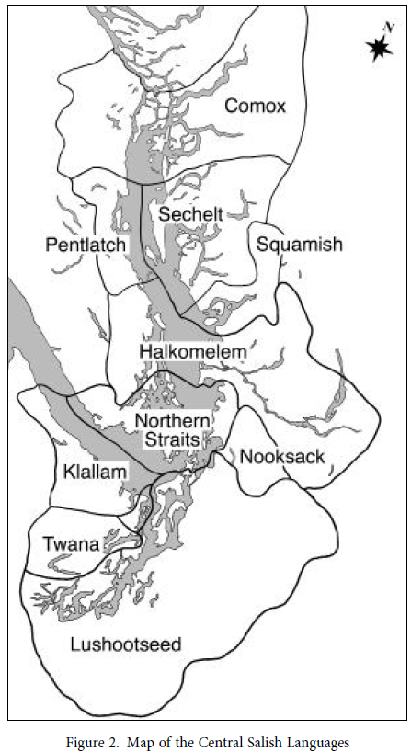

K’ómoks First Nation (n.d.) also shares that Kwak̓wala, a neighbouring Wakashan language, contributed to linguistic changes in the area as well through mutual borrowings as trade and marriage between these Peoples became more common (Figure 2).

Figure 2. Language histories among K’ómoks and Pentlatch (K’ómoks First Nation, n.d.)
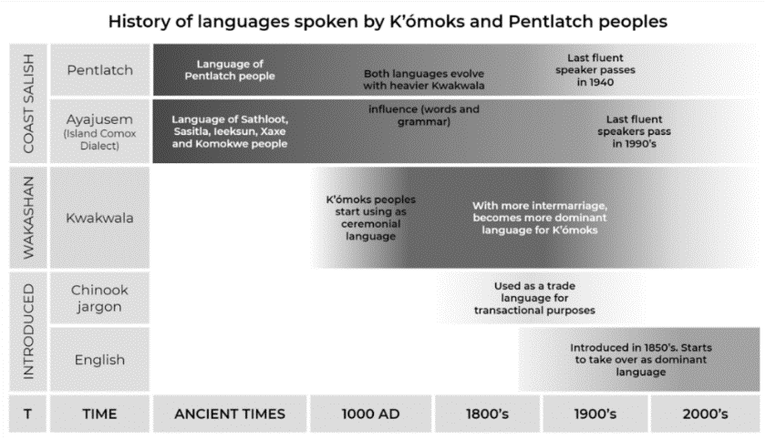

These cross-linguistic interactions, as well as the development of Chinook Wawa (Chinook Jargon) as a lingua franca throughout the region may also have implications for contemporary understandings of Pentlatch grammar and its lexicon.

Franz Boas materials

Franz Boas arrived in Pentlatch territory on November 12, 1886 and was there until December 3 (Kinkade 2008: 84). There are records of two Pentlatch-speaking families where he visited and another family living further south (Boas et al., 2006: 236). During this trip, speakers chose to share words as well as stories in Pentlatch, creating a series of 9 stories in total (Kinkade, 2008: 85). Boas’ original materials still exist at the American Philosophical Society (APS) along with their translations to German and English. The stories that create the basis for this research seem to be originally translated to German and are included at the end of the APS’s Item S2j.3 (Boas, ca. 1890: 95-103). Various edits to the conventions used for transcribing Pentlatch are outlined at the beginning of the stories here and are reflected throughout the stories (Figure 3).

Figure 3. Edited conventions to Pentlatch story transcriptions

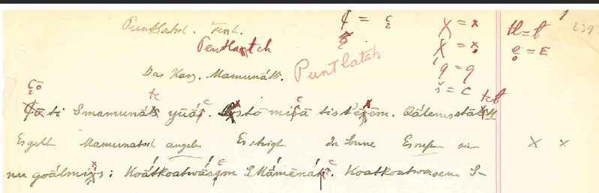

When these changes were made and by whom does not seem to be recorded. It is also unclear at what stage the English translations were produced, and by extension, whether they were translated from the original Pentlatch or the German translations of the texts.

- Positionality

Positioning one’s self relative to one’s work informs a researcher’s questions, motivations, approach, and conclusions. Therefore, sharing a description of these personal foundations recognizes how our experiences and learning may shape our approach to our work and helps to describe the type of work that we may be best positioned to contribute to.
I am fourth generation English and Nikkei (Japanese Canadian) settler in what is currently Canada. I was raised in North Delta, B.C. on the territories of Kwantlen, xʷməθkʷəy̓əm (Musqueam), Katzie, Semiahma (Semiahmoo), sc̓əwaθən məsteyəxʷ (Tsawassen), Stz'uminus, and kʷikʷəƛ̓əm (Kwikwetlem) Peoples. I did most of my post-secondary schooling in amiskwaciwâskahikan (Edmonton) on Treaty 6 territory. I arrived at the University of Alberta’s Linguistics department knowing that my goal in learning about linguistics was to be able to support language reclamation, so I was able to take as many classes as were offered on these topics and complete my minor with the Faculty of Native Studies. My training as a non-Indigenous student, primarily in linguistics, shapes my approach to the work that was asked of us in this course and the skills that I felt I might be able to contribute. I have been fortunate to be involved with a variety of transcription projects and in the past year have also been a part of the Huron-Wendat Nation’s ongoing language reawakening and reclamation. This experience has provided me with more insight into the variety of questions that must be asked when working with legacy materials that have been mediated by someone else who may have only had limited exposure to the language they represented in writing.
This project presents a different version of “community-based” language revitalization work than what is typically described (Czaykowska-Higgins, 2009; Leonard & Haynes, 2010; Rice, 2018), but nonetheless aims to adhere as much as possible to the spirit of community-based work as expressed by these scholars. Because this project was developed as part of a course with a number of students developing individual projects, the project is designed to address a research topic that was recommended and deemed relevant by the community-based team and also strives to provide a product in the form of transcribed stories which can support their future research goals. Calling my project “a preliminary analysis” recognizes that my knowledge, as a linguistics student with no prior experience working with Salishan communities, can only contribute so much. The Reawakening Pentlatch team may have perspectives that differ from my own conclusions and lead this research in a new direction. This respect for different types of expertise is central to this research and is fundamental to a scientific approach to knowledge-building.

- Methods

In the absence of active collaboration with the Pentlatch language team, my research was guided by general principles of relevance by selecting a topic that was suggested by the community-based team, responsibility to the Pentlatch community and their language, and respect for their heritage materials, the people who created them, as well as my classmates. Another component of this research aimed to engage collaboratively with my peers, through Microsoft Teams by sharing the working transcriptions and my research about motion auxiliaries to try to contribute to the collective knowledge of our class for the benefit of everyone’s final research and, in the end, to benefit the Reawakening Pentlatch team’s continued work. This approach is informed by Gardner (2012) and Wilson (2007) who stress the importance of community benefit, respect for all beings involved in the research process, responsibility for our work, and a sense of recognition that we ourselves are also growing through our engagement in this type of reciprocal research.
This research was grounded in examples of the Pentlatch language that are shared in the series of Pentlatch stories, recorded from pages 22–34 of Item S2j.1 (Boas, ca. 1910). The choice to engage with stories to address the research question of motion auxiliaries is linguistically motivated by the more naturalistic language used in a narrative as opposed to more direct elicitation. Regardless of any errors in transcription or gaps in the original researcher’s knowledge of the language, stories allow the reader to identify patterns in the text and see how possible wordforms or morphemes can actually function in a variety of contexts. This is of particular importance in developing a better understanding of meaning among unstandardized transcriptions and translations and in understanding the grammatical function(s) of auxiliaries. Furthermore, the decision to work with stories is also based on the community’s inclusion of cultural goals as part of the plan presented by the Reawakening Pentlatch team to our class. Stories represent fuller information about the worldviews, histories, and cultural understandings of the speakers than wordlists and isolated elicitation are likely able to do.
This approach is also supported by scholars such as Jo-ann Q’um Q’um Xiiem Archibald (2008) and Margaret Kovach (2021). Each of these scholars have written extensively about the knowledge, relations, and methods embedded within stories and “storywork”. Archibald (2008:112) talks about “the power of story to ‘be the teacher’ through the relationships that it holds between the story itself, the storyteller, and the engaged listener or reader. She sees storywork as having a role in cultural, spiritual, social, and emotional learning, as well as part of linguistic, and pedagogical work (Archibald, 2008: 148). By transforming stories into a digital format, the stories themselves—and by extension the people who shared them—become reconnected to the contemporary language work programs and the Pentlatch descendants learning from them.

- Ethics

Article 9.21 of the Tri-Council Policy Statement (TCPS2) on Ethical Conduct for Research Involving Humans (Canadian Institutes of Health Research, Natural Sciences and Engineering Research Council of Canada, and Social Sciences and Humanities Research Council of Canada 2018: 130) states that information that is within the public domain does not require community engagement or research ethics board (REB) review. That being said, it is still recommended that researchers whose work may impact the identity or heritage of communities minimize the potential harms that could arise without an appropriate understanding of the materials and the contexts that created them. These recommendations are reinforced by the generalized OCAP® principles for data protection and use outlined by The First Nations Information Governance Centre (FNIGC) which recognizes the inherent sovereignty that First Nations have over the “data” that their collective knowledge has helped to create. These principles include the ownership of cultural knowledge, control that communities should have over research and data management of their cultural resources, access to the information about their own People and authority to make decision about access for others, and physical possession of the materials to assert ownership.
In the case of this project, although the materials used fall within the public domain, notice was given to the APS which currently holds the materials involved in this research, and an invitation to work with these documents was extended by the contemporary Reawakening Pentlatch team from Qualicum First Nation. In addition to the invitation to engage with the materials, the Pentlatch team also shared background information about their own involvement in reawakening their language and a list of ideas that could serve as a starting point to develop class research projects. Their suggestions ensured that we could shape our research around topics that have been deemed relevant at this stage in the community’s language reclamation process and also reflect a recognition of the Pentlatch language team’s ownership and control of their cultural heritage. The inclusion of transcription as a component of my project also works towards making “access” more meaningful. The stories will no longer be static images, but can become materials able to be transformed further by the community and to be easily interacted with. The products and conclusions of my research project will be returned to the Pentlatch language team with copyright assigned to the appropriate body or group and any local copies of the materials will be deleted once they are submitted to the team. This ensures that they have physical ownership of the materials created through this research process and maintain control and authorship of future understandings of their heritage language.

- Research process

Transcription

The first step in transforming these stories was to develop a method for representing them in a way that would reflect meaningful symbol distinctions in the transcription while also maintaining the structures embedded in the original resource (Lukaniec, 2022: 321). This included identifying the special characters to best represent the transcriptions with consensus among the class. Decisions about the symbols used were carried out over Microsoft Teams by creating a file to discuss possible symbol distinctions and a final document to capture the conventions. By deciding on a unique Unicode character for each visually distinct symbol in the transcriptions, the Pentlatch community team will be more easily able to edit these materials by finding and replacing select symbols as more becomes known about the sounds of the language and how the transcribed symbols might represent them. One case that remains unresolved is that of t-like characters (Figure 4).

Figure 4. Variation in “t” symbols

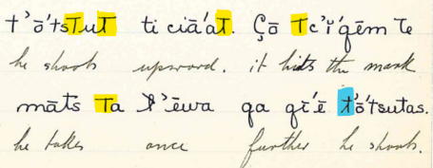

Although these t-symbols appear visually different, more comparative work is required to determine whether these might actually represent different speech sounds, or if they were just a result of the transcriber’s handwriting. For now, visual distinctions have been maintained as < t >, < ᴛ >, and < ƛ >.
With regards to the structure of the transcriptions, the digital version mirrors the meaningful connections represented in the source material (i.e., which English translations map to which Pentlatch form(s)) as recommended in Lukaniec (2022). This also facilitates referencing back to the source material. The only instances where the original form was not maintained, are in cases where a Pentlatch word had been separated across two lines of text due to the limitations of the physical page. In some cases, the English translation for a single Pentlatch word were also separated across lines. This not only made the Pentlatch forms difficult to search and analyse, but also misrepresented the mapping of the English translation where a single Pentlatch form corresponds to more than one English word (e.g., Figure 5).

Figure 5. Example where Pentlatch “smɑ̄'ealitc” spans two lines

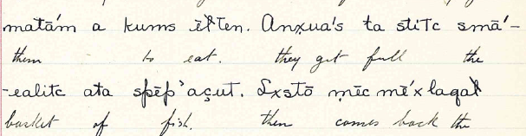

Identification of Pentlatch motion auxiliaries

Once the stories were transcribed, this project focused on identifying Pentlatch motion auxiliaries (Appendix A). Wordlists and elicitation provided supplementary examples for forms that were not clear in the stories. Anderson (2006, 2011) describes auxiliary verbs as an element that combines with another verb, creating a monoclausal verb phrase. Anderson (2011: 796–77) adds that within these constructions, the auxiliary verb contributes a grammatical meaning and the main verb contributes the main lexical meaning of the verb phrase, but the order of these elements can differ.
Based on this definition, I identified motion auxiliaries through the apparent semantics of English translations and the Pentlatch syntactic structure where a first verb is semantically weakened (contributing some grammatical function) and the second predicate contributes the main meaning of the clause. For example, çō is glossed as ‘go’ when it is used as a lexical verb as in (1), and also appears to play a grammatical role in other contexts (2).

(1) Lxstō çō ᴛciɑ̄'o te ɬɑ̄x́ɬai qa anx̣ua'stō
then go beach det fir conj takes
te qulē'ɬ
det pitch
‘Then goes to the beach the fir and takes the pitch.’
(Boas, ca. 1910: 22, line 4)

(2) Çō ēmɑ̄'cia ɑ̄te slɬɑ̄'nai
aux walk det woman
‘He went to get a woman.’
(Boas, ca. 1910: p. 23, line 2)

The ‘come’ auxiliary was more difficult to isolate and identify originally from the stories alone. There were four reasons for this unanticipated challenge: the ‘come’ auxiliary mē does not appear as a lexical predicate which would have been more likely to have a clear translation; the placement of English translations does not align mē with the meaning ‘come’ as illustrated in example (3a) which translated mē as ‘and’; mē was often transcribed as part of the lexical verb as in (3b), and; lastly, other morphology is transcribed as attached to the auxiliary or between the auxiliary and lexical verb as demonstrated in example (3c).

(3) | a. | Mē | tĭ'tctē | sēxnɑ̄'tcia
 |  | aux | cover | fallen.trees
 |  | ‘And it covers trees fallen over.’
(Boas, ca. 1910: 23, line 11)

(3) | b. | Qē | ɑ̄nūɬ | ṃēnuē'lem
 |  | 3.sg? | take.hand | aux -to.enter
 |  | ‘He takes the hand they go in.’
(Boas, ca. 1910: 29, line 3)

(3) | c. | Mēsē | lō'lōm | was | mē'csē | cōk’ōm
 |  | aux -fut? | sing | when? | aux - fut? | wash
 |  | ‘They will sing when(?) they come to wash.’
(Boas, ca. 1910: 28, line 7)

These challenges encouraged me to refer to the wordlists to see if the more isolated forms found in S2j.3 (Boas, ca. 1890) could help me to pick out the ‘come’ motion verb. Page 6 of the English to Pentlatch wordlist includes multiple entries meaning ‘come,’ but it became clear that mē was the form being used in a motion auxiliary role within the stories.

‘Come’ and ‘go’ auxiliaries in Central Salish

My next steps included a comparative approach to look at the corresponding motion auxiliary forms in Pentlatch’s sister languages. This research was shaped in part by the geographical proximity of these languages as illustrated above in Figure 1, as well as the availability of resources for other Central Salish languages. Most of these resources had grammar components that specified these words’ roles as auxiliaries, but the forms in Sḵwx̱wú7mesh sníchim are included from dictionary entries and Lushootseed forms were identified from stories. In these cases, information about the function of the words as auxiliaries is not provided, but the words translated as ‘come’ and ‘go’ are proposed cognates to at least one of the existing sets of forms in Table 1.

Table 1. Motion auxiliaries in select Central Salish languages

Language | ‘go’ | ‘come’ | Source
ʔayʔaǰusəm (Island) | só | qʷʌlʔ | Harris, 1981: 47
ʔayʔaǰuθəm (Mainland) | θu / hu | qʷəl’ | Watanabe, 2003: 90
Shishálh | tsu / tsútsu | kwetl’ | Beaumont, 2011: 91
Hul’q’umi’num’ | nem’ | m’i | Schneider, 2021: 395
hən̓q̓əmin̓əm̓ | ném̓ | ʔem̓’í / m̓i | Suttles, 2003: 36
Sḵwx̱wú7mesh sníchim | huy̓, nam̓ | (h)em̓í, m̓i | Jacobs & Jacobs, 2011: 245, 268
Lushootseed | ʔux̌ʷ | ʔeƛ’ | Lamont et al. 2014: 113, 491

Considering these forms relative to the identified Pentlatch motion auxiliaries, it seems likely that the Pentlatch word for ‘go,’ çō/çū, is cognate with the form that is more common in the north and likely shares a proto-form with ʔayʔaǰusəm (Island dialect), ʔayʔaǰuθəm (Mainland dialect), and Shishálh. However, the Pentlatch word for ‘come,’ which has been transcribed as mē, appears more likely to be related to the more southern forms shown for Hul’q’umi’num’, hən̓q̓əmin̓əm̓, and Sḵwx̱wú7mesh sníchim. This division among the motion auxiliary system raises questions about the histories of each of these auxiliaries, when their meanings each shifted from their more lexical meanings of ‘come’ and ‘go’ to be grammaticized and behave as auxiliaries, and whether the other halves of the northern and southern cognate sets might also have cognates in Pentlatch whose meanings have shifted in another way.
These data also seem to support the “wave-like” distribution discussed in Hess (1979) that proposes an explanation of different cognate sets across the Central Salish branch of the language family. Hess (1979: 10) suggests that linguistic innovations are travelling downriver via Halkomelem and that changes move outward from here. As an effect, more southernly languages like Lushootseed often share similarities with sister languages further north in Central Salish-speaking regions, like ʔayʔaǰusəm. Although the Lushootseed word for ‘go’ appears to be unrelated, the verb for ‘come’ ʔeƛ’ could be a cognate with northern forms: qʷʌlʔ, qʷəl’, and kwetl’.

Functions of auxiliary verbs

Another aspect of the comparative survey of sister languages’ motion auxiliary verbs included an overview of the grammatical functions that these auxiliaries are reported to have. This type of grammatical insight was available from resources describing ʔayʔaǰusəm, Shishálh, Hul’q’umi’num’, and hən̓q̓əmin̓əm̓. The functions of motion auxiliaries in these languages are summarized below:

Table 2. Comparative functions of motion auxiliaries

Language | ‘go’ | ‘come’ | Source
ʔayʔaǰusəm (Island) | Instead of or in addition to the future marker to indicate future action. | Coming from a distance (motion toward). | Harris, 1981: 47
Shishálh | Instead of or in addition to the future marker to indicate future action. | Also means "become" or "start(ing) to appear/grow/etc." | Beaumont, 2011: 176, 652
Hul’q’umi’num’ | Motion away from the speaker or movement forward in time | Motion toward the speaker or events just now taking place | Schneider, 2021: 395
hən̓q̓əmin̓əm̓ | Motion away from the speaker or "be going to (do something) | Motion toward the speaker or "becoming" | Suttles, 2003: 36-37

Using these attested functions of the motion auxiliaries in related languages as a starting point, it seems possible that Pentlatch uses motion auxiliaries in similar ways (see Appendix A, column D for full analysis). For example:

‘go’ as an indication of future action:
(4) | a. | Çō | sētc | ɬᴇxuaɬa | ta | sᴇlɑ̄'ɬ
 |  | aux | fut? | arrive-?? | det | lake
 |  | ‘You will arrive at a lake.’
(Boas, ca. 1910: 28, line 6)

‘go’ as representing motion away:
(4) | b. | Çu | yō'o | te | jō'i
 |  | aux | home | det | boy
 |  | ‘He goes home the boy.’
(Boas, ca. 1910: 27, line 7)

‘come’ indicating becoming:
(4) | c. | Ṃēṇɑ̄'t
 |  | aux-night
 |  | ‘It gets dark.’
(Boas, ca. 1910: 29, line 8)

‘come’ as representing motion toward:
(4) | d. | Te | hē'uᴛcis | ta | sqɑ̄'lmix̣. | Mē'iyō'ō
 |  | 3.pl | row | det | people | aux-home
 |  | ‘They row the people. They come home.
(Boas, ca. 1910: 33, line 7)

It is worth noting that in (4a), the morpheme between the auxiliary and main verb ‘arrive’ may be the future marker. If this is the case, it could be that the motion auxiliary is not the part of this construction contributing the grammatical meaning of future. It is noted in ʔayʔaǰusəm and Shishálh that the ‘go’ auxiliary can be used to indicate future action “instead of or in addition to” the future marker (Beaumont 2011: 176; Harris 1981: 47). Unfortunately, there are no clear examples of çō/çū being used alone in Pentlatch to indicate future that confirms the same is true in Pentlatch.
There are also Pentlatch examples from the stories that seem to differ from the ways that each motion auxiliary would function in other Central Salish languages. For example, one of the functions of the ‘come’ auxiliary marks ‘becoming,’ but there is also an example in the Pentlatch stories where the ‘go’ auxiliary seems to serve this function, as shown in (5).

(5) | Ti | çō | sxuō'm | ti | k’ōɬkō
 | 3.sg? | aux | dry | det | ocean
 | ‘It becomes dry the ocean.’
(Boas, ca. 1910: 25, line 1)

Similarly, it is possible that Pentlatch shows examples of the ‘come’ auxiliary being used to express motion away (6) or something that will happen (7) which are functions typically described as being associated with the ‘go’ auxiliary.

(6) | Lxstō | mēs | pᴇɬᴇmᴛᴇm | tē'tce | nuqua'lmix̣sōɬ
 | then | aux | ascent-?? | ?? | all.people
 | ‘Then they are torn away by the current all people.’
(Boas, ca. 1910: 26, line 4)

(7) | Mēsē | lō'lōm | was | mē'csē | cōk’ōm
 | aux-fut? | sing | when? | aux - fut? | wash
 | ‘They will sing when(?) they come to wash.’
(Boas, ca. 1910: 28, line 7)

Again, example (7) may include a future marker which raises the question of whether this is a function of the motion auxiliary in Pentlatch or if the future marker is doing all of the work in these situations. If it is determined that only the future marker is contributing this meaning, the grammatical function of the çō and mē in these examples remains unclear. Particularly in (7), mē does not seem to clearly contribute a sense of becoming, motion toward, or events ‘just happening now.’

Auxiliary constructions

This comparative method to analyse the meaning or function of motion auxiliary verbs was also used to develop an understanding of the syntactic constructions these auxiliaries are a part of (Appendix A, column E). In descriptions of these constructions in other Central Salish languages, Schneider (2021: 395) notes that in Hul’q’umi’num’, auxiliaries do not feature any inflectional morphology, but that any necessary inflection would appear on the following lexical predicate. However, in Pentlatch there are examples where additional morphology appears connected to the motion auxiliary verb. Watanabe (2003: 90) seems to confirm that this is possible in ʔayʔaǰuθəm in his description of auxiliaries attracting “edge-positioned” morphemes which he illustrates in (8):

(8) | ʔut | -čxʷ | -k’ʷa | x̣ič | -i | -t
 | if | 2.sg.indc | quot | point | -lv | -ctr
 | ‘If you point at him...’
(Watanabe, 2003: 90)

Watanabe (2003: 90–94) also details that not all ʔayʔaǰuθəm auxiliaries function as predicates, that more than one auxiliary can appear in an auxiliary verb construction (so long as their meanings do not contradict one another), and that auxiliaries can also follow the lexical predicate.
The decision to look at different word orders in proximity to auxiliary verb constructions came from a noticeable variation in the syntax and lack of familiarity with these other markers to understand what can be expected to co-occur with auxiliary verbs. Decisions around word order may reflect particular storytelling or discourse practices, but further research would be needed to develop a stronger theory of how word order is used in Pentlatch stories. Examples of these differences are below, with (9) illustrating a more common construction, (10) showing additional morphology between an auxiliary and following lexical predicate (possibly Watanabe’s (2003:90) “edge-positioned” morphemes), and (11) demonstrating what seems to be a third-person singular pronominal marker starting a sentence before the auxiliary.

(9) | Çō | -'u | ɬuq | a | te | slɬɑ̄'nai
 | aux | ?? | find | det | det | woman
 | ‘He finds a woman.’
(Boas, ca. 1910: 23, line 3)

(10) | Çō | -kua | ɬ̣ɑ̄'tctas
 | aux | ?? | put.in.front.of?
 | ‘She goes to put it in front of him.’
(Boas, ca. 1910: 30, line 3)

(11) | Tu | çus | ɑ̄'xīs | qīē
 | 3.sg? | aux | sleep | again
 | ‘He goes to sleep again.’
(Boas, ca. 1910: 30, line 4)

Challenges and limitations

As with all approaches and circumstances, this research was not without some challenges and limitations that are worth stating explicitly. In terms of my own approach, many of the stories were of a similar genre, meaning that they were set in a particular time and therefore used a particular tense, and also largely focused on recounting narratives that happened to third-person characters. This leaves a gap for understanding how these constructions might work in more conversational settings where first- and second- person speech would be more common.
In the case of motion auxiliaries, part of this challenge was in trying to conceptualize how an auxiliary that functions to mark motion toward or away from the speaker would be represented in third person stories. Are there different ways to view space or motion that may help to understand the division of the use of çō/çū as opposed to mē within these texts?

- Conclusion
The main goals of this research were to transform the stories that were shared with our class into a long-term product that can be easily searched, edited, and sorted through as the work of the Reawakening Pentlatch team continues, and to address their requests to develop some understanding of motion auxiliaries in the language. Although my project does not present final conclusions, I hope that this presentation of the different examples that were identified from the stories and the accompanying comparative research provide a variety of linguistic lenses through which to consider how Pentlatch motion auxiliaries “work” and what they look like in context.
From work with the stories, two motion auxiliaries have been identified in Pentlatch, çō/çū meaning ‘go’ and mē meaning ‘come’. Looking at related languages, it seems likely that the Pentlatch çō/çū, is cognate with the same auxiliary as ʔayʔaǰuθəm (Island and Mainland), and Shishálh. However, mē appears more likely to be cognate with Hul’q’umi’num’, hən̓q̓əmin̓əm̓, and Sḵwx̱wú7mesh sníchim. In terms of the functions that these auxiliaries serve, it seems that there are examples in Pentlatch that align with the many functions described in sister languages. However, there are also instances where the translations suggest that one motion auxiliary may also take on the function that sister languages associate with the other auxiliary. Lastly, a review of the syntax surrounding motion auxiliaries reveals that there is more to be learned about the types of constructions that are attested in Pentlatch. More research is needed to understand the meaning of surrounding words and morphemes in order to develop a knowledge of grammatical motion auxiliary usage in the context of these stories.
Another possible path for other future research could include to review of the materials relative to the German translated versions of the stories (Boas, ca. 1890: 95-103) which indicates amended orthographic decisions and could provide additional insight with regard to the English translations. Alternatively, one could try to analyse the variation between çō and çū, to determine whether anything, phonological or otherwise, was conditioning these changes. Regardless of the future directions of this work, I hope that the discussion above and the materials shared with Pentlatch team serve as a source to develop and explore new questions and understandings of Pentlatch motion auxiliaries for the communities today who are working to bring their language back into use.

References

Anderson, G.D.S. (2011). Auxiliary verb constructions (and other complex verb types): A functional-constructional overview. Language and Linguistics Compass, 5(11), 795–828.
–––––. (2006). Auxiliary verb constructions. Oxford Scholarship Online. https://doi.org/ch7kqk
Beaumont, R. C. (2011). Sechelt dictionary. Sechelt Indian Band.
Boas, F. (ca. 1890). Pentlatch materials. American Council of Learned Societies Committee on Native American Languages, American Philosophical Society (Item S2j.3), American Philosophy Society, Philadelphia, PA, United States.
–––––. (ca. 1910). Comox and Pentlatch texts. American Council of Learned Societies Committee on Native American Languages, American Philosophical Society (Item S2j.1), American Philosophy Society, Philadelphia, PA, United States.
Boas, F., Bouchard, R., Kennedy, D., & Bertz, D. (2006). Indian myths & legends from the North Pacific coast of America: A translation of Franz Boas' 1895 edition of Indianische Sagen von der Nord-Pacifischen Küste Amerikas. Talonbooks.
Canadian Institutes of Health Research, Natural Sciences and Engineering Research Council of Canada, and Social Sciences and Humanities Research Council of Canada, Tri-Council Policy Statement: Ethical Conduct for Research Involving Humans, December 2018.
Czaykowska-Higgins, E. (2009). Research models, community engagement, and linguistic fieldwork: Reflections on working within Canadian Indigenous communities. Language Documentation & Conservation, 3(1), 15–50. http://hdl.handle.net/10125/4423
Discover Vancouver Island. (n.d.) Hornby Island. https://www.discovervancouverisland.com/regions/gulf-islands/hornby-island/
First Nations Information Governance Centre. (n.d.). The First Nations Principles of OCAP®. https://fnigc.ca/ocap-training/
Gardner, S.E.B. (2012). The four R’s of leadership in Indigenous language revitalization. In C. Kenny & T.N. Fraser (Eds.) Living Indigenous leadership: Native narratives on building strong communities (pp. 125–135). UBC Press.
Hess, T. (1979). Central Coast Salish words for deer: Their wavelike distribution. International Journal of American Linguistics, 45(1), 5–16. https://doi.org/10.1086/465569
Harris, H. R. (1981). A grammatical sketch of Comox. [Ph. D. disseratation, University of Kansas]. ProQuest.
Jacobs, P. & Jacobs, D. (2011). Skwkwú7mesh sníchim xwelíten sníchim : Skexwts Squamish-English dictionary. University of Washington Press.

Kinkade, D. (2008). The Pentlatch myth corpus. In M. T. Thompson & S. M. Egesdal (Eds.) Salish myths and legends: One People’s stories (pp. 84–103). University of Nebraska Press.
Kiyosawa, K., & Gerdts, D. (2010). Salish applicatives. Brill.
K’ómoks First Nation. (n.d.) Cultures. https://komoks.ca/cultures/
Lamont, M. W., Krise, E. C., James, A. J., Sam, E., Beck, D., & Hess, T. (2014). Tellings from our Elders: Lushootseed Syəyəhub. UBC Press.
Leonard, W., & Haynes, E. (2010). Making “collaboration” collaborative: An examination of perspectives that frame linguistic field research. Language Documentation & Conservation 4, 268–293. http://hdl.handle.net/10125/4482
Lukaniec, M. (2022). Managing data from archival documentation for language reclamation, In A. L. Berez-Kroeker, B. McDonnell, E. Koller, & L. B. Collister (Eds.), The open handbook of linguistic data management (pp. 315–325). The MIT Press. https://doi.org/gnzrxm
Rice, K. (2018). Collaborative research: Visions and realities. In S.T. Bischoff & C. Jany (Eds.), Insights from practices in community-based research (pp. 13–37). De Gruyter Mouton. https://doi.org/hwsp
Schneider, L. (2021). Classifying multi-verb constructions in Hul’q’umi’num’ Salish. Papers for the international conference on Salish and neighbouring Languages, 56, 392–409.
Suttles, W. (2004). Musqueam reference grammar. UBC Press.
Vance, E. (2019, December 30). ‘Breathing new life’ into language culture in the Qualicum First Nation and beyond. Vancouver Island Free Daily. https://www.vancouverislandfreedaily.com/news/breathing-new-life-into-language-culture-in-the-qualicum-first-nation-and-beyond/
Visit Denman Island. (n.d.) History. https://visitdenmanisland.ca/about-denman-island/history/
Watanabe, H. (2003). A morphological description of Sliammon, Mainland Comox Salish with a sketch of syntax. Endangered Languages of the Pacific Rim.
Wilson, S. (2007). Guest editorial: What is an Indigenist research paradigm? Canadian Journal of Native Education 30(2): 193–195.

Appendix A

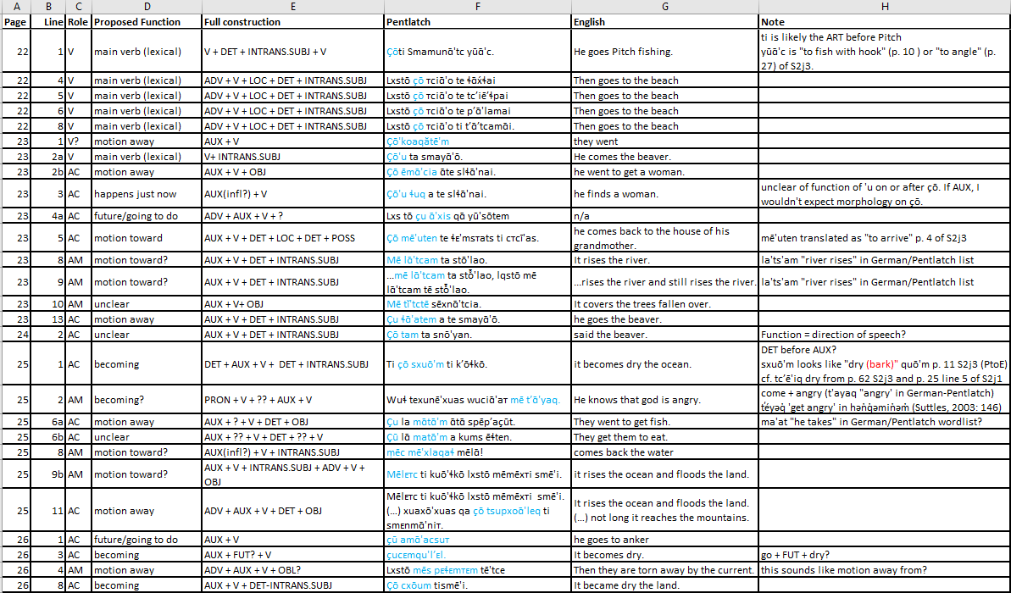
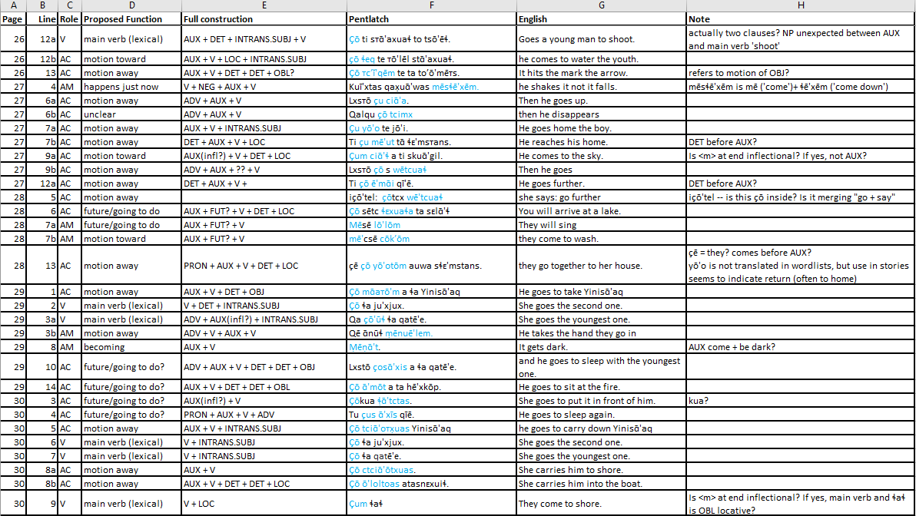
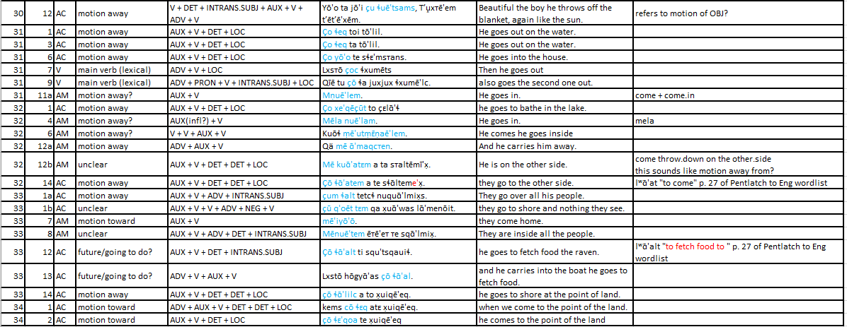

Thank you to the Reawakening Pentlatch Team for their generous invitation for our LING 431/531 class to engage with their heritage language and materials over the course of this past semester. I hope that the work that has been produced through this process reflects our appreciation of the trust and opportunity given to us as students. Thank you to Su Urbanczyk for guidance and feedback in this process.
Abbreviations in paper and appendix: 2= second person, 3 = third person, ADV = adverb, AUX = auxiliary, DET = determiner, CONJ = conjunction, CTR = control transitive, FUT = future, INDC = indicative subject, INTRANS.SUBJ = intransitive subject, LOC = location, LV = link vowel, NEG = negation, OBJ = object, OBL = oblique, POSS = possessor, PRON = pronominal, QUOT = quotative; SG = singular, V = lexical verb
This language would likely be pronounced as ʔayʔaǰusəm in the Island dialect, rather than ʔayʔaǰuθəm (Mainland dialect). ʔayʔaǰusəm will be used in this paper to refer to the Island dialect.

