I hope to use the following 5 images in “In Plain Sight: Documenting Immigration Detention in Canada.”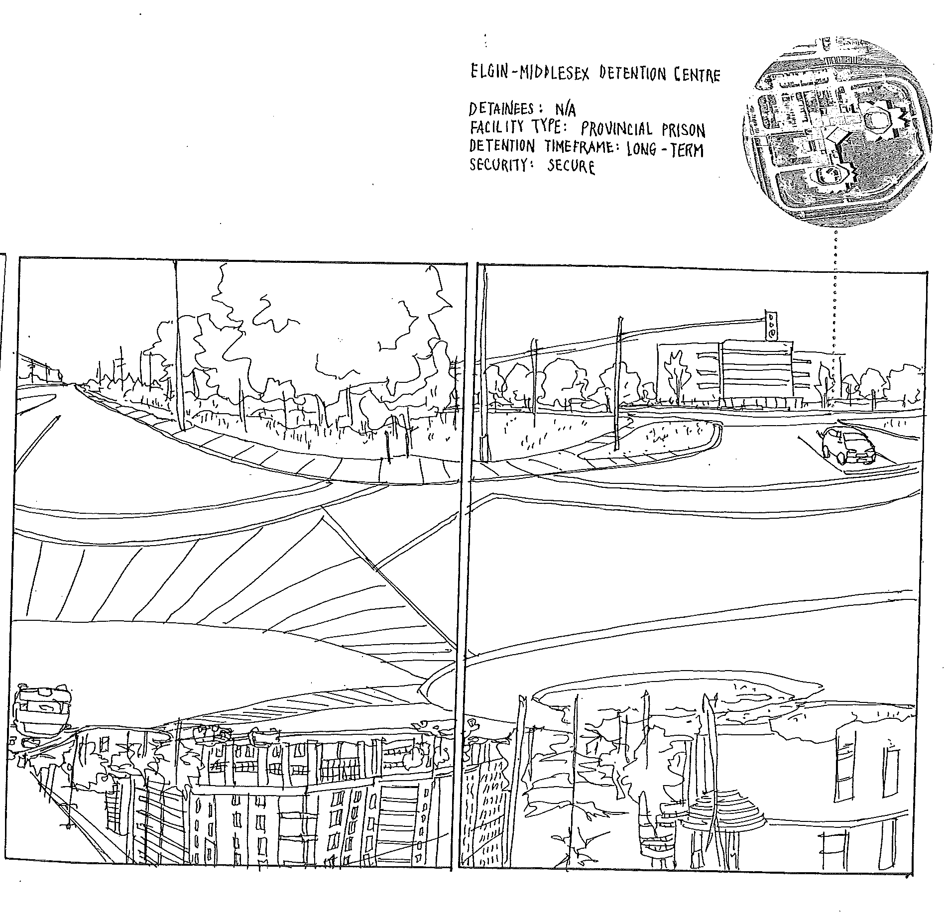
Figure 1 (Chak 17)
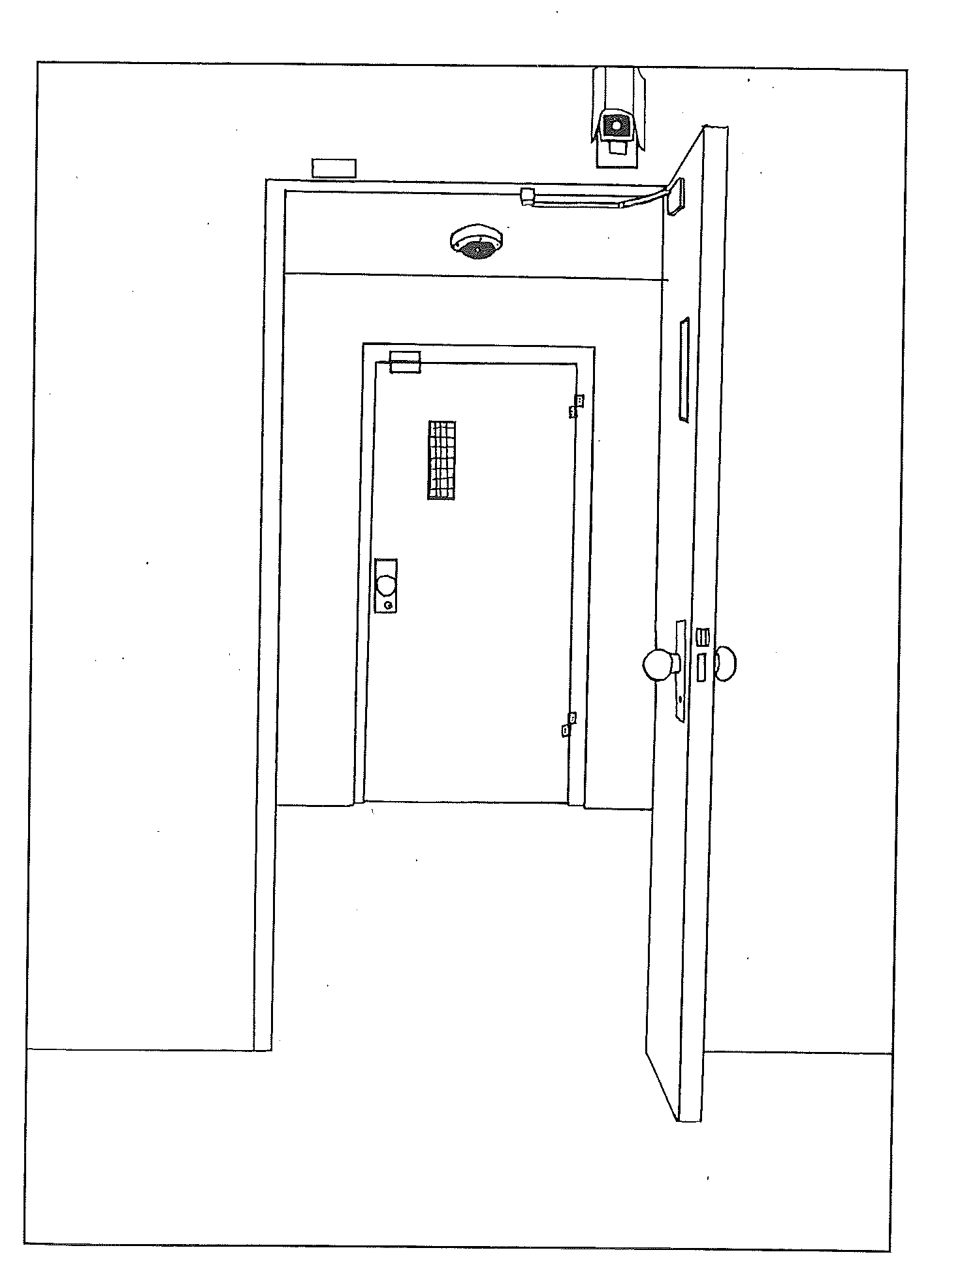
Figure 2 (Chak 39)

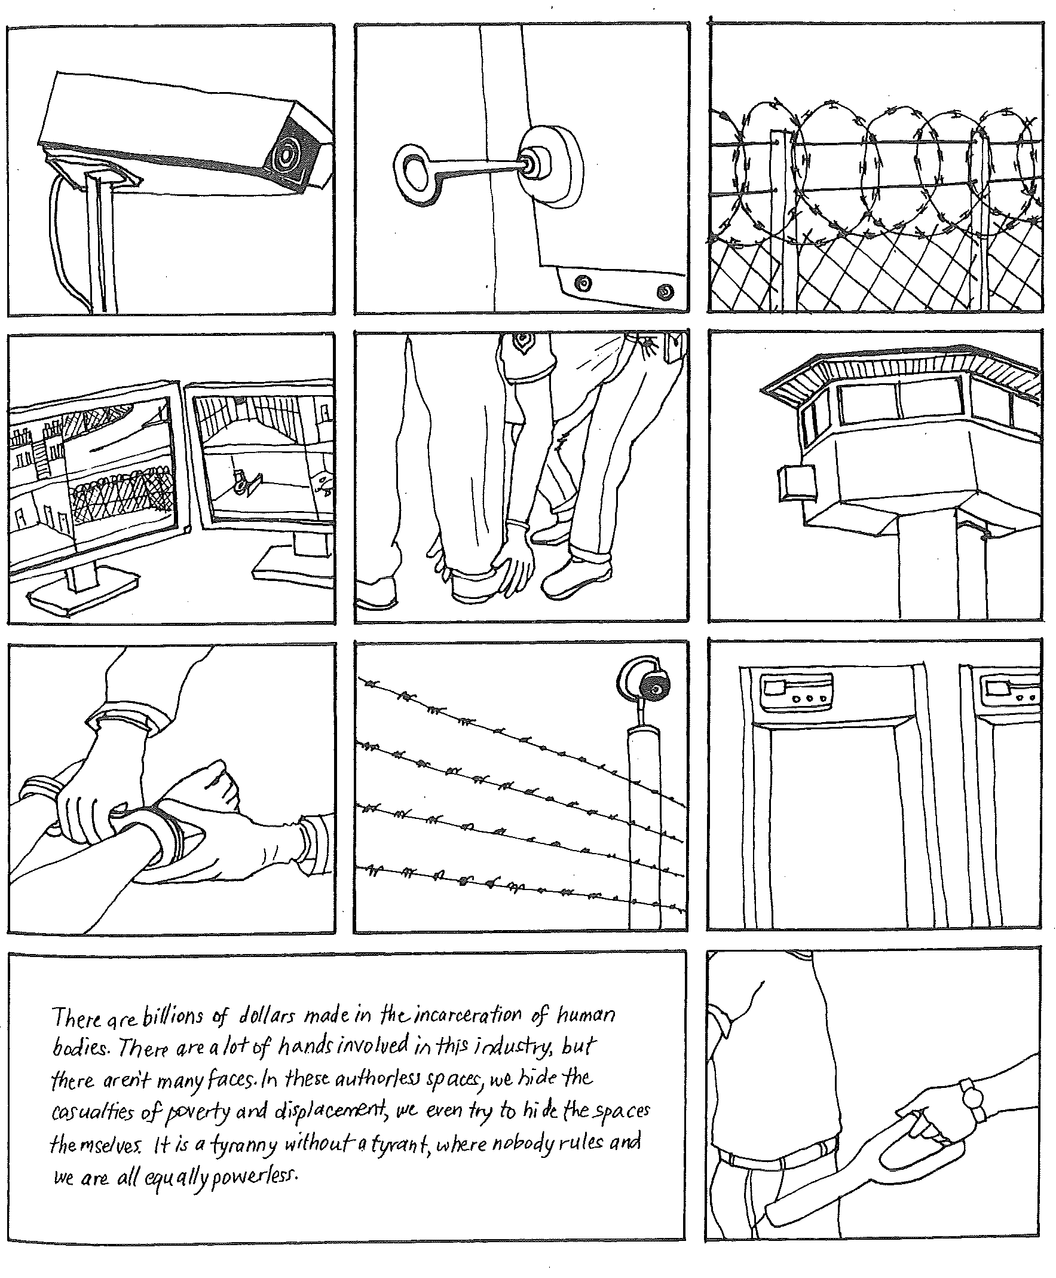
Figure 3 (Chak 91)
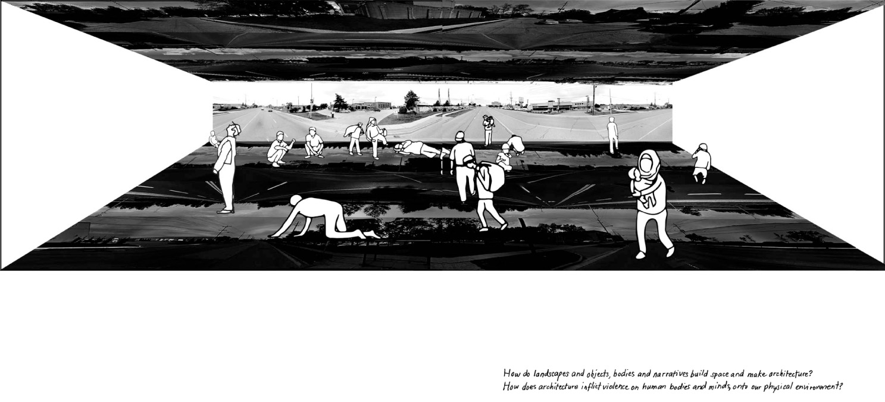
Figure 4 (Chak 86-87)

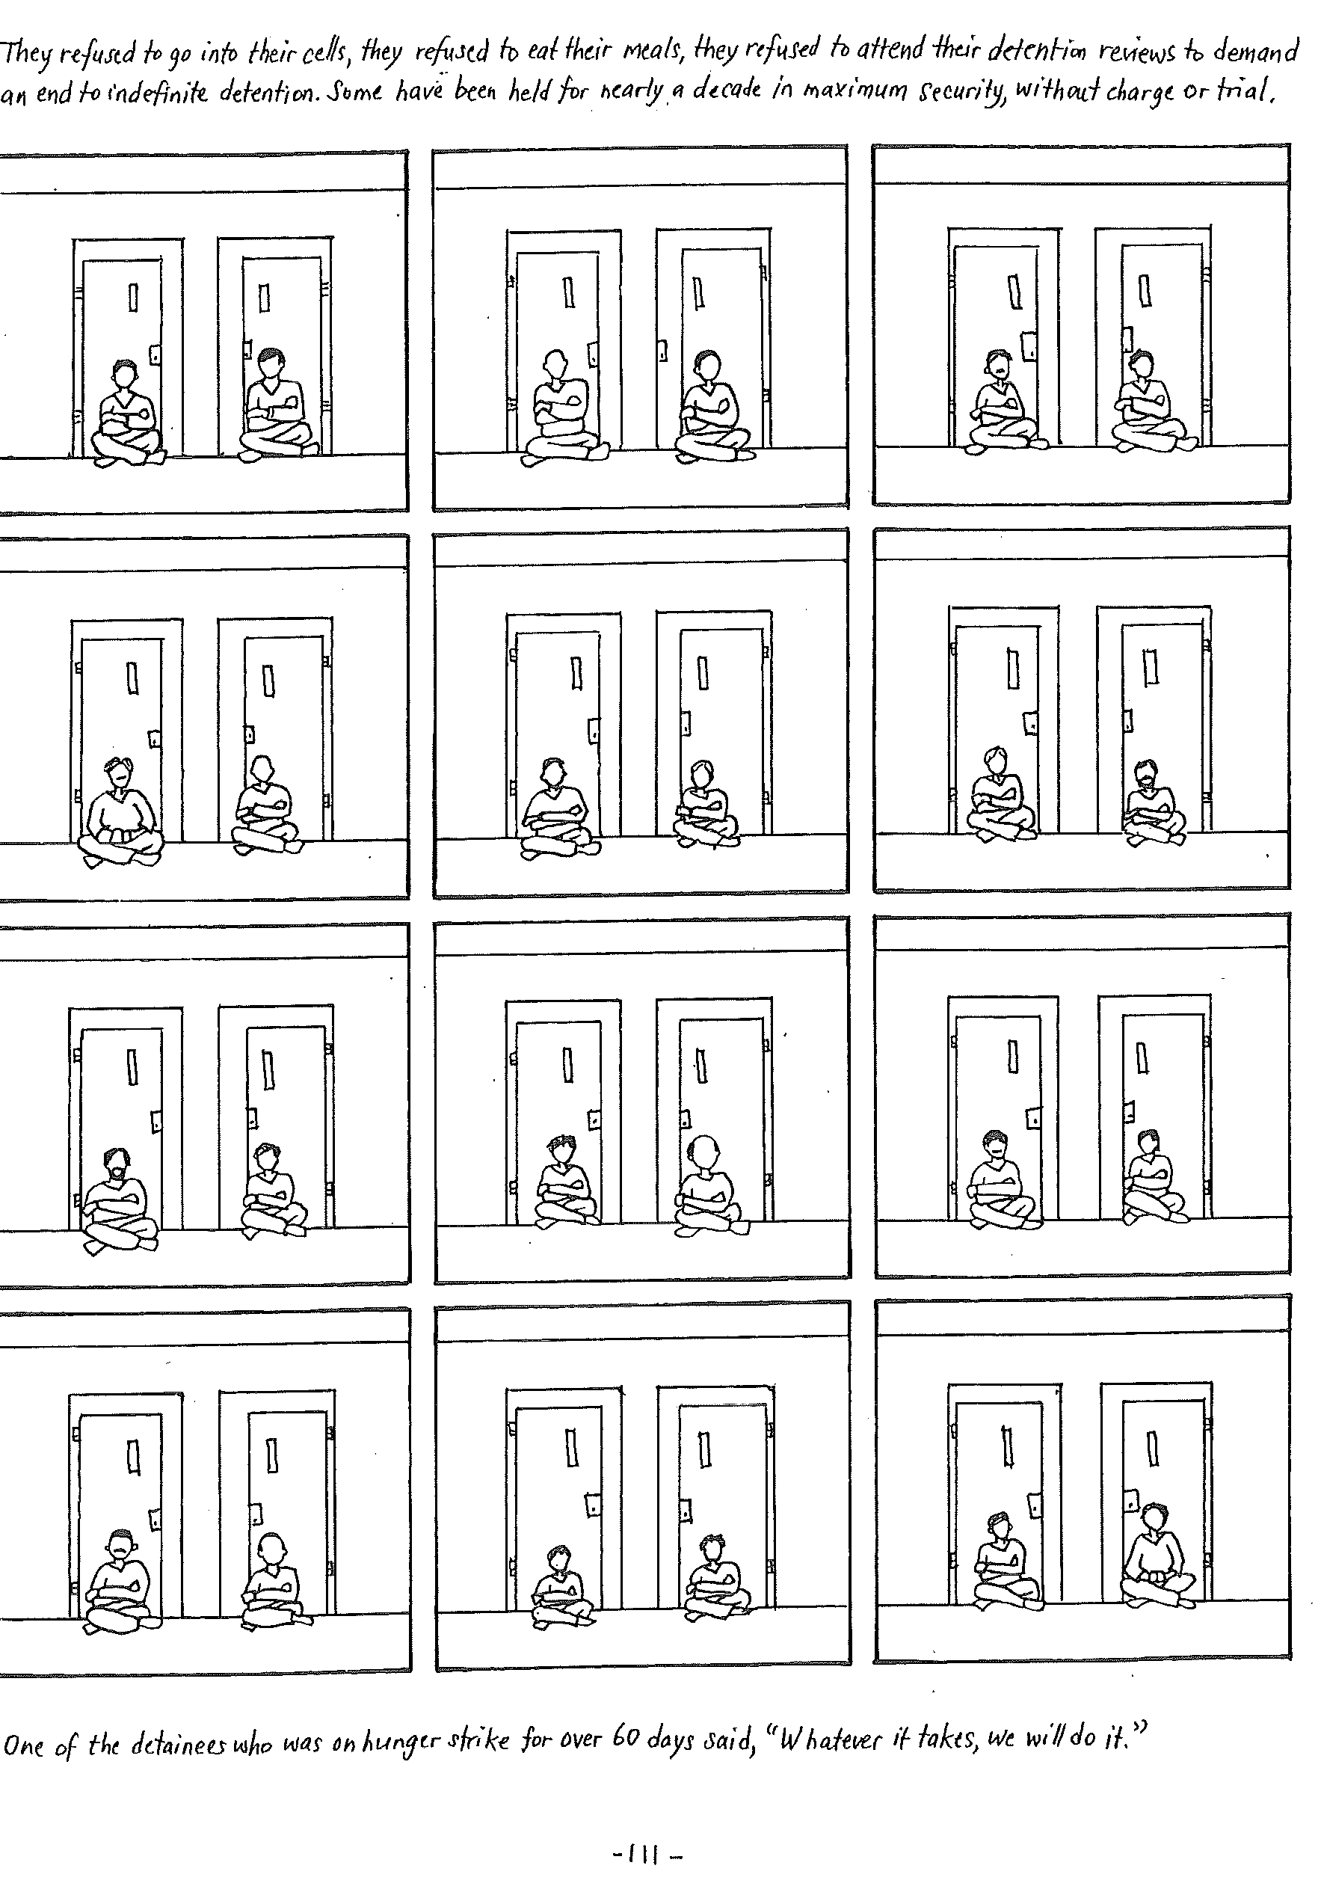
Figure 5 (Chak 111)

